Here are two examples. They are aimed at GCSE students but can easily be adapted for younger or older pupils :

1572 : SHOULD ELIZABETH I EXECUTE MARY QUEEN OF SCOTS ?
This activity focuses on Elizabeth I’s decision whether to execute Mary Queen of Scots in 1572.
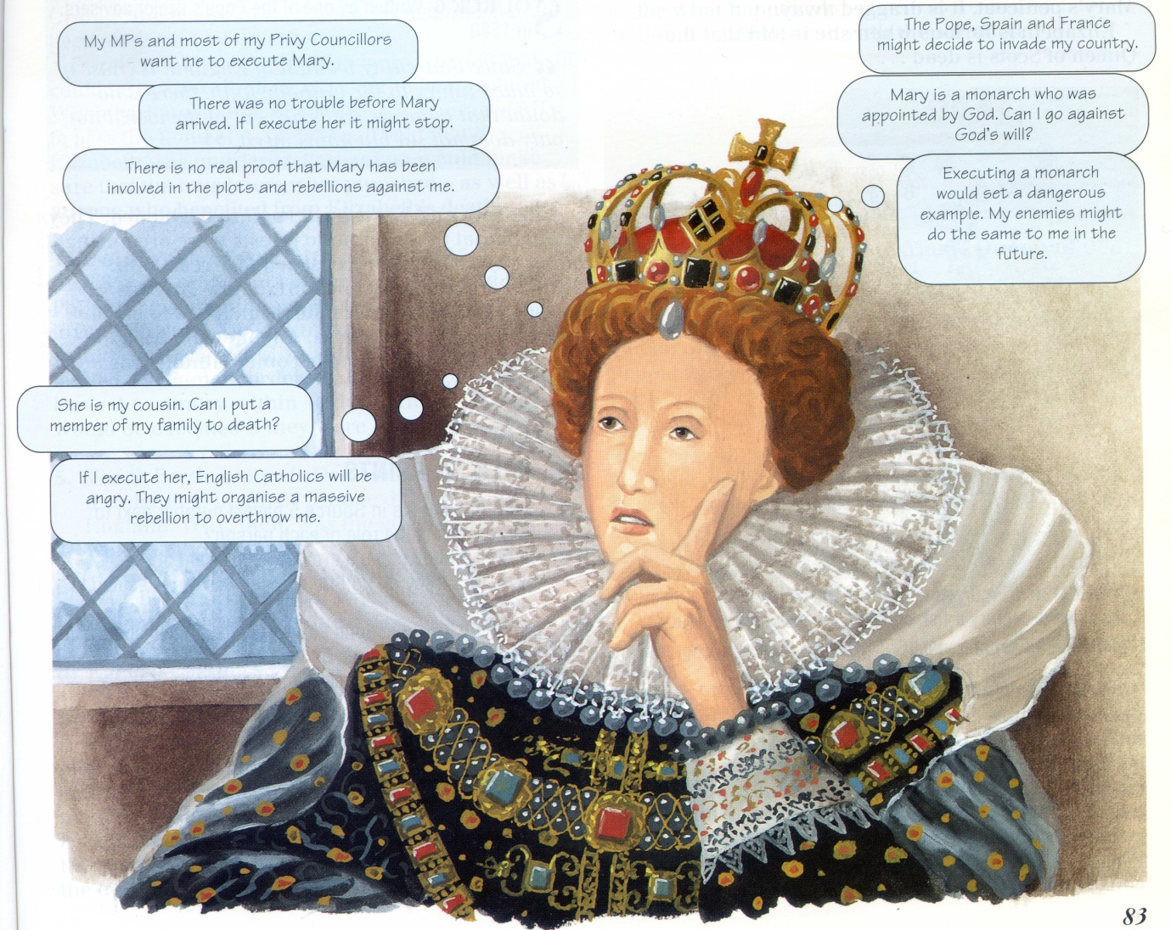
From ‘Elizabethan England, A Study in Depth’, Hodder Murray 1999
Prior learning : pupils need to know about the rivalry between Catholics and Protestants in the 16th century, why Mary, Queen of Scots was a threat to Elizabeth and the series of events which had followed her arrival in England in 1568 - and culminated in Parliament’s demands for Mary’s execution in 1572.
The activity : Pupils should examine MPs’ demands from Elizabeth’s point of view and make lists of the advantages and disadvantages of executing Mary. When they have made their decision they could prepare a short speech to announce it to the Privy Council.
Follow-up work : After finding out that Elizabeth decided not to execute Mary in 1572, pupils should examine what happened afterwards, between 1572 and 1587, to help them explain why Elizabeth did eventually agree to execute Mary, Queen of Scots.

1935 : What should Hitler do next ?
A series of decisions made by Hitler and the Nazis after 1935 helped to plunge Europe into the Second World War. This is the first of a series of mini-activities about these decisions. They place pupils in the position of Hitler and his advisers at the time and will help them to understand the high-risk strategy they pursued.
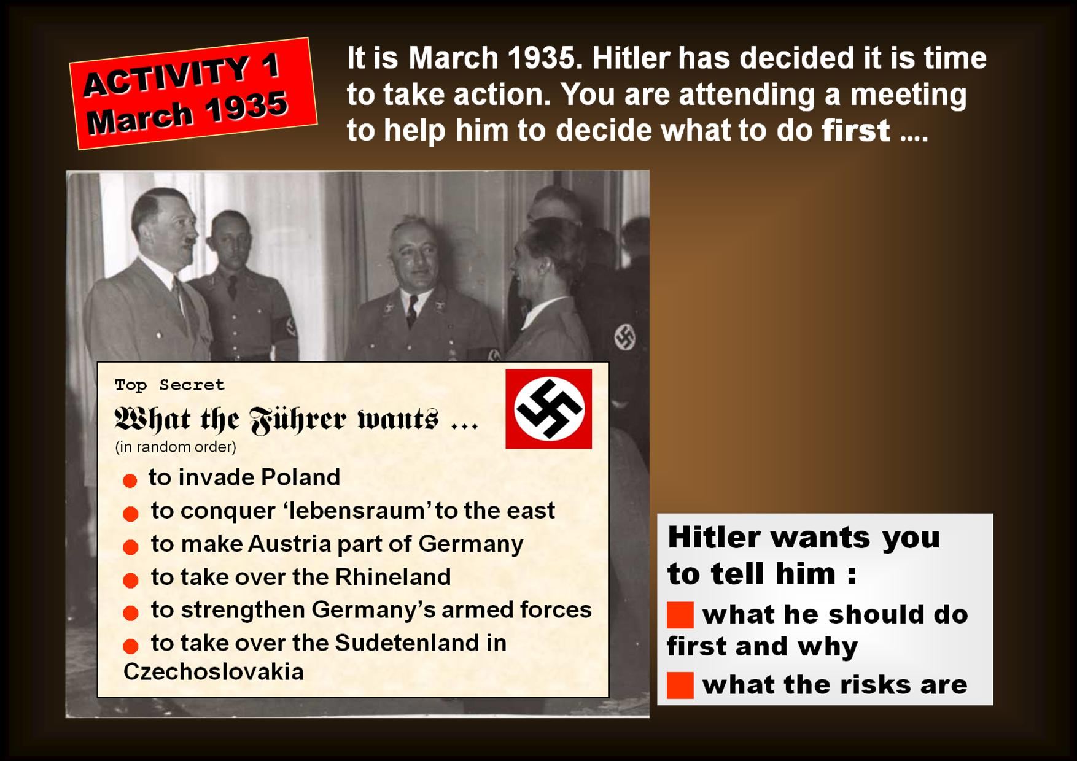

Prior learning : Pupils should know about the main terms of the Treaty of Versailles, Hitler’s rise to power and his vision of how to make Germany ‘great’ again.
The activity : This activity is set in March 1935. Hitler has been in power for just over two years and has eliminated his rivals inside Germany. Now he is turning his attention to foreign policy. Pupils are provided with a list of Hitler’s foreign policy goals. They have to discuss the advantages and disadvantages of each option at this particular time, before advising him which one to choose and what the risks are. They could present their conclusions in the form of short speeches or letters.
When they have made their decisions, inform them that the chosen decision in March 1935 was to strengthen Germany’s armed forces ; pupils should discuss why they think that decision was taken and not any of the others.
Follow-up work :
You could devise similar mini-activities for Hitler’s other major foreign-policy decisions before the outbreak of war : March 1936 (the Rhineland), March 1938 (the Anschluss), September 1938 (the Sudetenland) and September 1939 (Poland). For each one pupils will need updates about what has happened since the previous decision – rather like a news-room simulation. For example, for March 1936 they will need to know about the build-up of Germany’s armed forces and the muted reaction of Britain and France.
After this sequence of activities pupils should investigate the broader causes of the Second World War, including the reasons for Britain and France’s policy of appeasement.

